Installation Video : How to Install MySQL Workbench in Windows - 👉 MySQL for Beginners

Step 1 : https://www.mysql.com/downloads/

Click the link in the browser
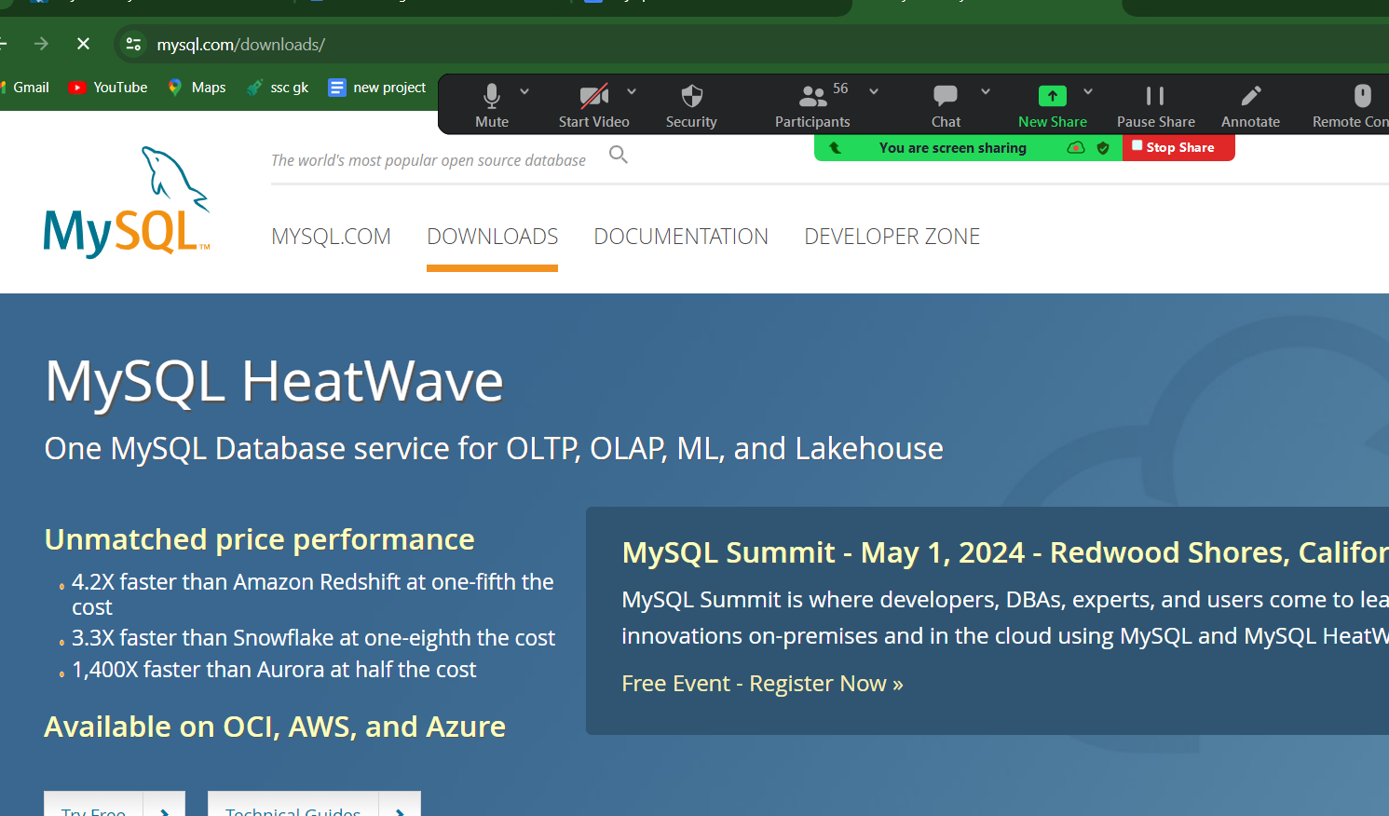

Step 2:
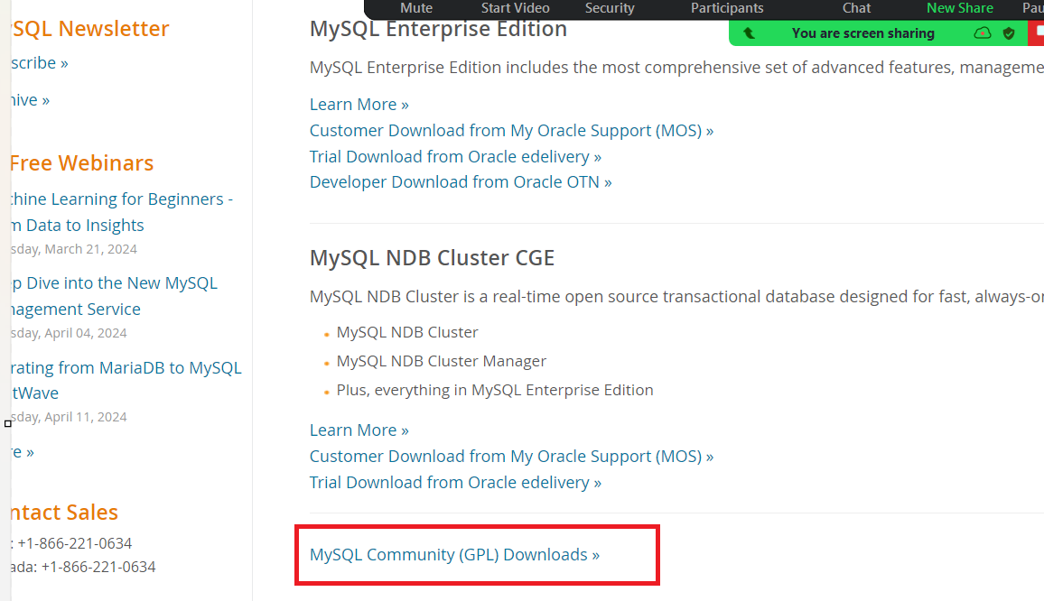

Step 3:
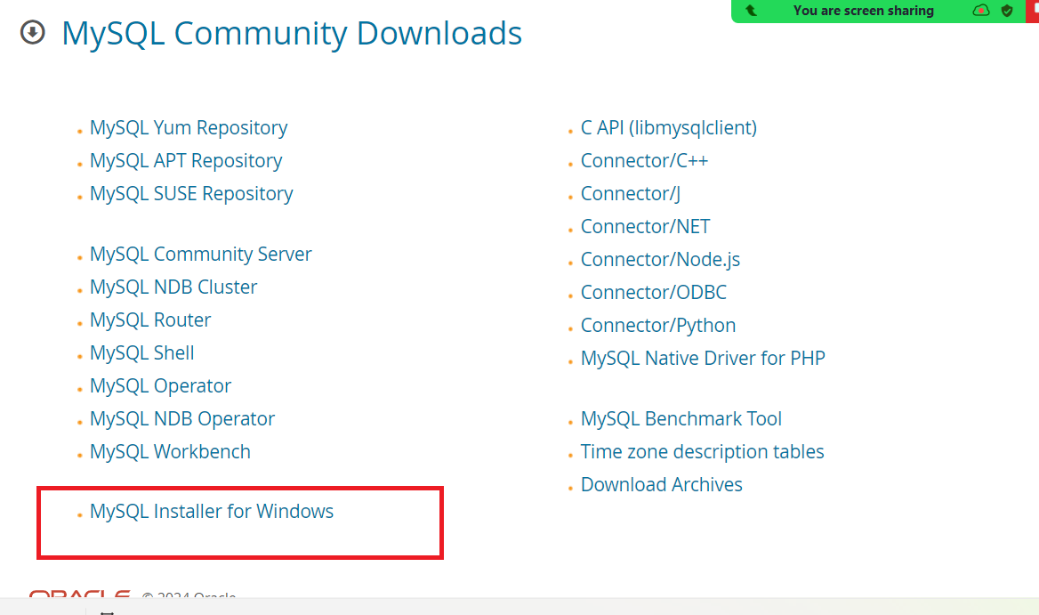

Step 4:
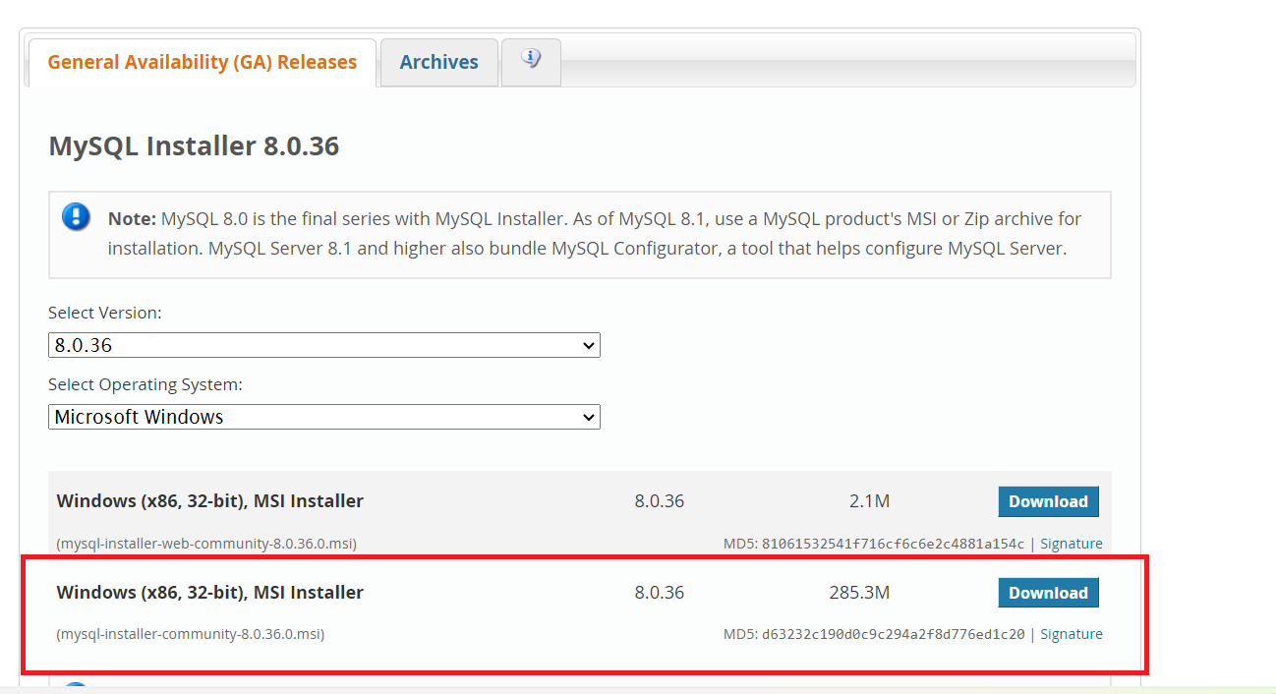

Step 5:
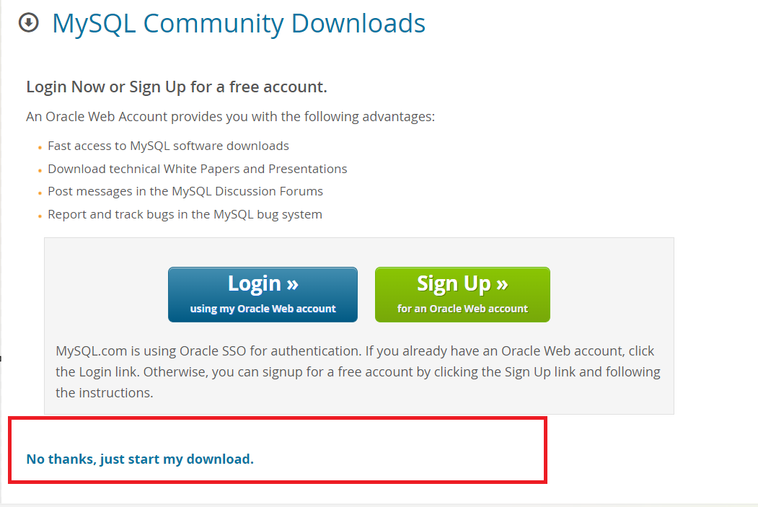

#your installation file will be downloaded in your local file after that kindly follow the below steps

Double click the file in your dowloads
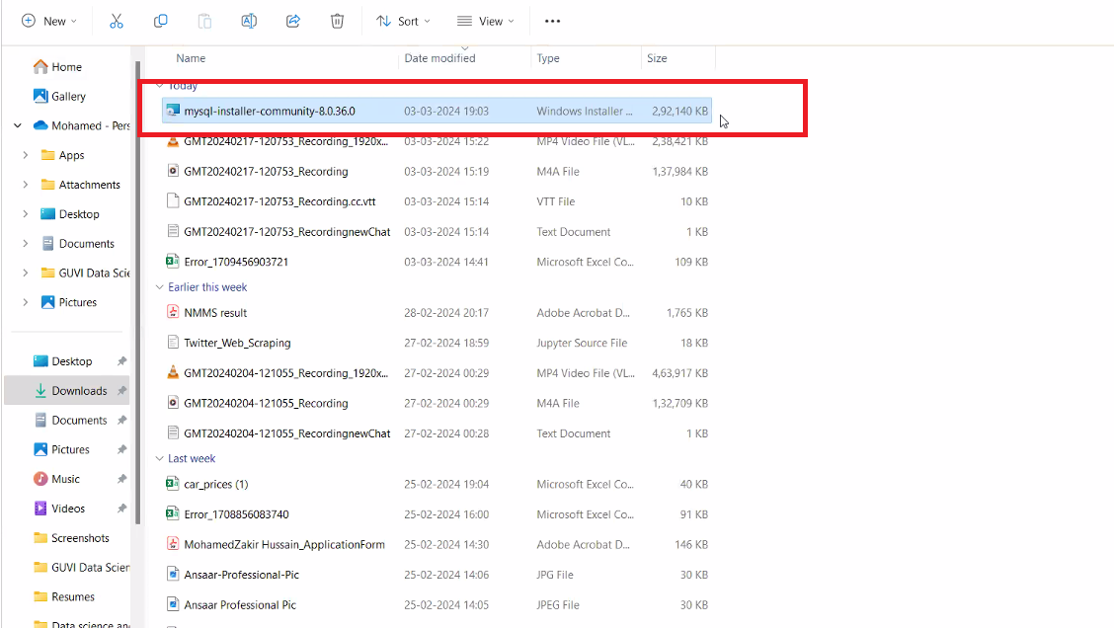

Step 6:

Select custom button and then press next button
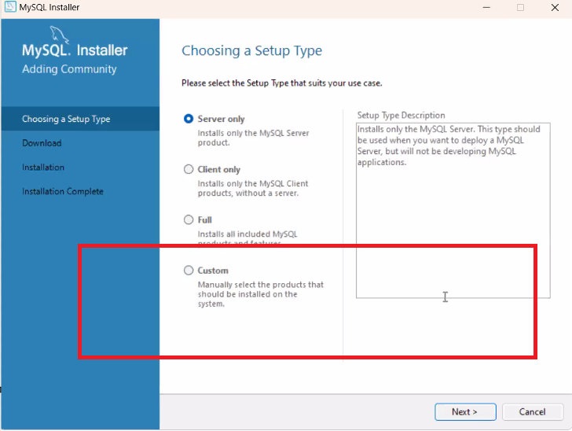

Step 7:
Kindly expand the mysql server to the last and finally select mysql 8.0.36 and then press green color right arrow
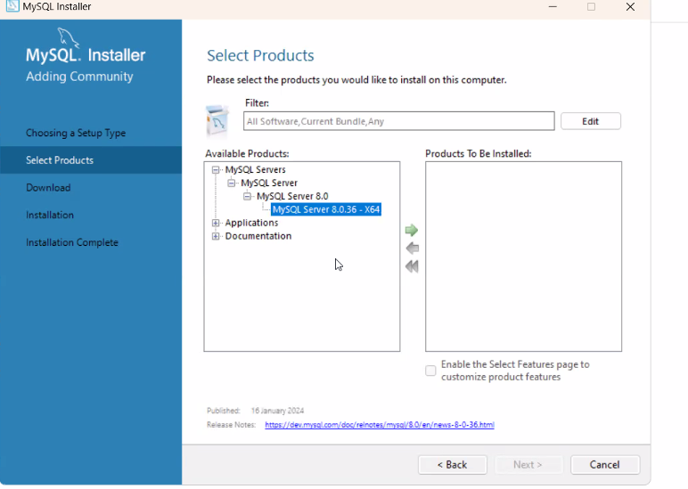
Step 8 :
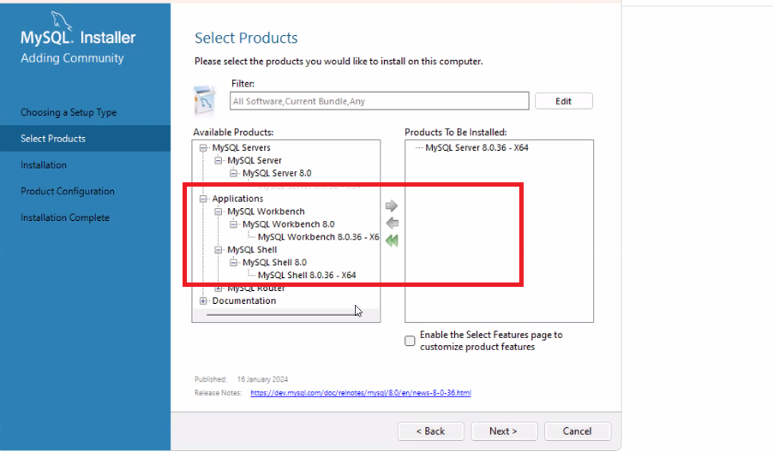

Step 9 👍
Kindly move the the last expanded one of application and musql shell to the right by selecting the right arrow
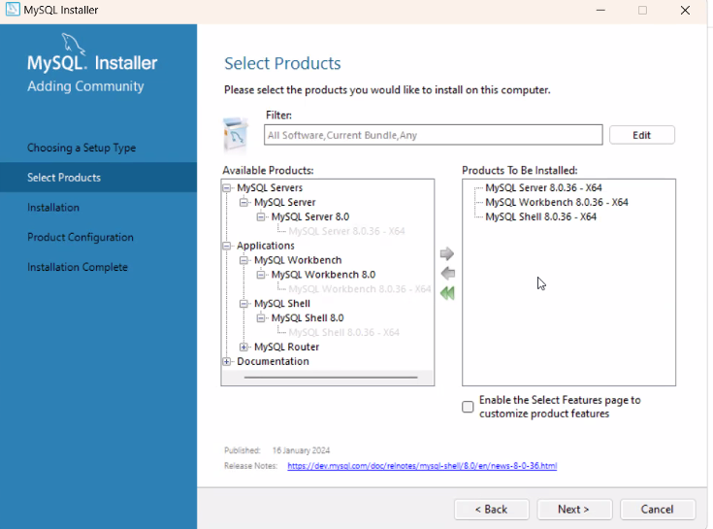

Step 10:
Press next and execute
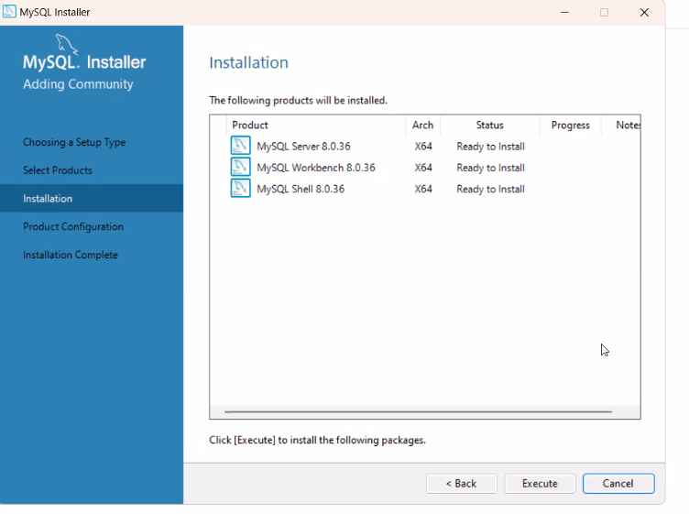

Step11:
Once installation completed select next
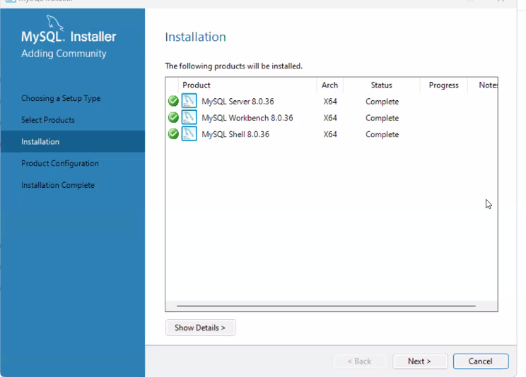

Step 12:
Keep on selecting next button till u reaches the below page

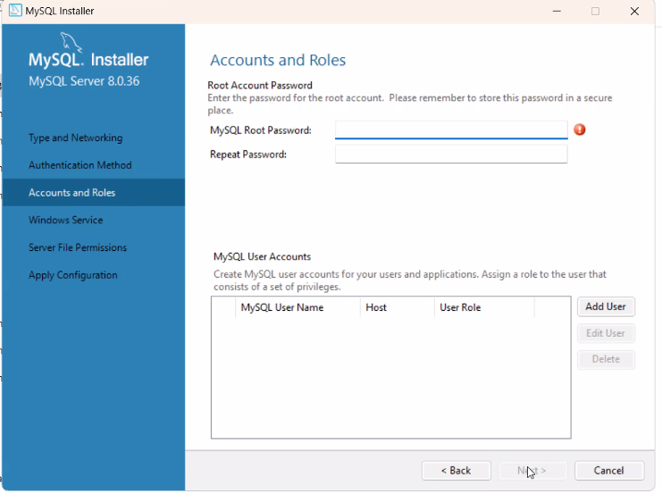

Step 13:
Select next
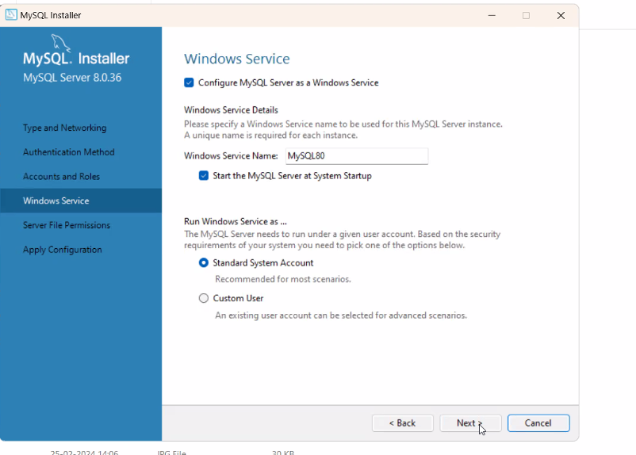

Step 14:
Select execute button and then after execution select finish button

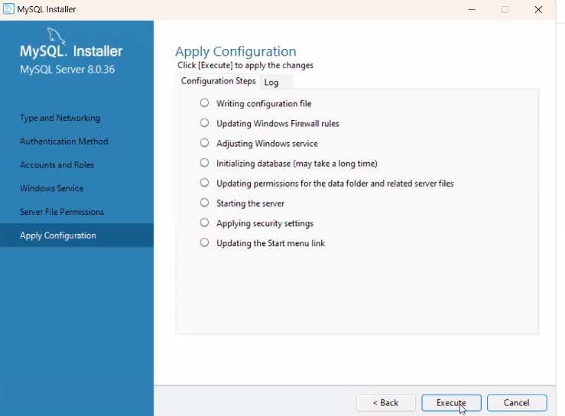

Step 15 :
Select next button
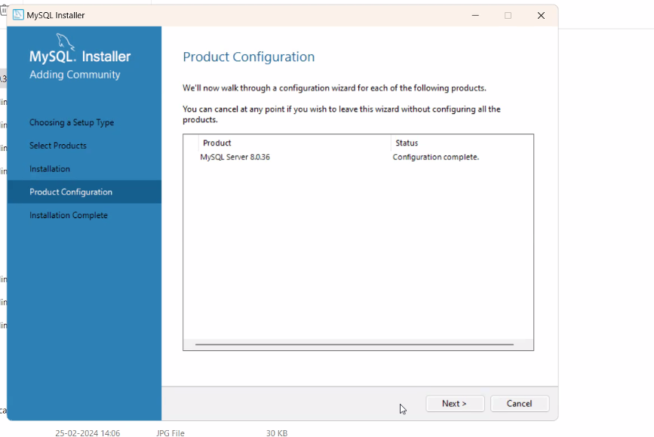
Step 16:
Select finish button
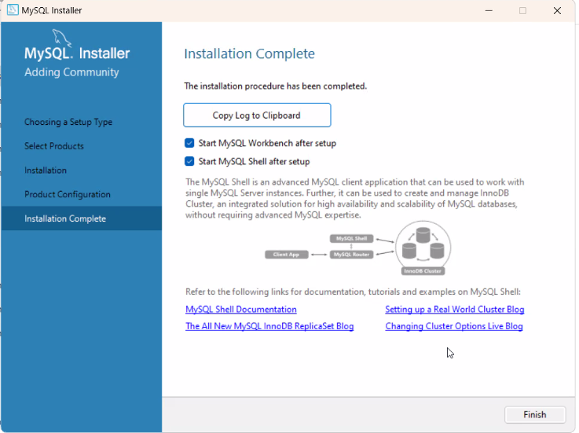

Step 17 :
Finally open this page to open mysql workbench for practice
